

✴

**Build empathy**

The information you add here should be representative of the observations and research you've done about your users.

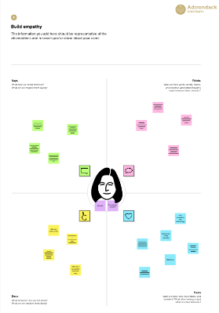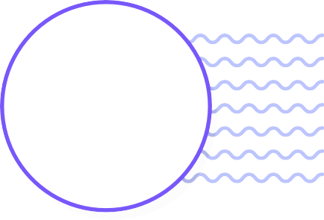

**Need some inspiration?**

See a finished version of this template to kickstart your work.

[**Open example**](https://app.mural.co/template/f44b7843-7c23-408c-bd36-7b0c9409dc20/96efd10c-81d2-401e-8072-4e87935e5d6b)

[**Share template feedback**](https://muralco.typeform.com/to/CiqaHVat?typeform-source=app.mural.co)

**Empathy map**

Use this framework to develop a deep, shared understanding and empathy for other people. An empathy map helps describe the aspects of a user's experience, needs and pain points, to quickly understand your users’ experience and mindset.

# Says

What have we heard them say? What can we magine them saying?

# Thinks

What are their wants, needs, hopes, and dreams? What other thoughts might influence their behavior?

Acquires signals from sensors converts to digital and processes the data.

Can greatly help in maintaining correct water quality?

Can it be trusted?

The system can monitor water quality automatically, triggers alarms immediately to prevent any health hazards.

Able to analyze data and respond appropriately?

Keeps the biologocal life safe

Can be of great help to the government in regulating the discharges

The sensor or whole system can fail

Analyze data

TEAM ID :PNT2022TMID22772

TOPIC : REAL TIME WATER MONITORING SYSTEM

**Template**

# Does

What behavior have we observed? What can we imagine them doing?

# Feels

What are their fears, frustrations, and anxieties? What other feelings might

influence their behavior?